MINOR PROJECT -INTRO TO RDBMS
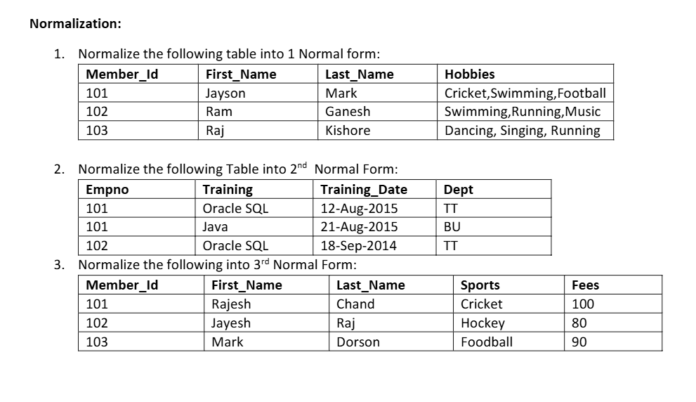
SOLUTION
1. Normalize the following table into 1NF
Given Table
Member_Id | First_Name | Last_Name | Hobbies
101 | Jayson | Mark | Cricket, Swimming, Football
102 | Ram | Ganesh | Swimming, Running, Music
103 | Raj | Kishore | Dancing, Singing, Running
Problem
The Hobbies attribute contains multiple values in a single cell. This violates First Normal Form (1NF), which requires every attribute to have only one (atomic) value.
1NF Table
Member_Id | First_Name | Last_Name | Hobby
101 | Jayson | Mark | Cricket
101 | Jayson | Mark | Swimming
101 | Jayson | Mark | Football
102 | Ram | Ganesh | Swimming
102 | Ram | Ganesh | Running
102 | Ram | Ganesh | Music
103 | Raj | Kishore | Dancing
103 | Raj | Kishore | Singing
103 | Raj | Kishore | Running

2. Normalize the following table into 2NF
Given Table
Empno | Training | Training_Date | Dept
101 | Oracle SQL | 12-Aug-2015 | TT
101 | Java | 21-Aug-2015 | BU
102 | Oracle SQL | 18-Sep-2014 | TT
Assume the composite primary key is (Empno, Training).
Problem
Dept depends only on Empno, not on the whole composite key. This is a partial dependency, violating Second Normal Form (2NF).
Convert into 2NF
EMPLOYEE Table
Empno | Dept
101 | TT
102 | TT
TRAINING Table
Empno | Training | Training_Date
101 | Oracle SQL | 12-Aug-2015
101 | Java | 21-Aug-2015
102 | Oracle SQL | 18-Sep-2014
Now every non-key attribute depends on the whole primary key.

3. Normalize the following table into 3NF
Given Table
Member_Id | First_Name | Last_Name | Sports | Fees
101 | Rajesh | Chand | Cricket | 100
102 | Jayesh | Raj | Hockey | 80
103 | Mark | Dorson | Football | 90
Problem
Assume:
- Member_Id → First_Name, Last_Name, Sports
- Sports → Fees
So,
Member_Id → Sports → Fees
This is a transitive dependency, violating Third Normal Form (3NF).
Convert into 3NF
MEMBER Table
Member_Id | First_Name | Last_Name | Sports
101 | Rajesh | Chand | Cricket
102 | Jayesh | Raj | Hockey
103 | Mark | Dorson | Football
SPORTS_FEES Table
Sports | Fees
Cricket | 100
Hockey | 80
Football | 90
Now, every non-key attribute depends only on the primary key and not on another non-key attribute.

